Dustin Kendall

kendalld@pnw.edu

Lab 5 ECE 371

ALU

# ALU Block Diagram

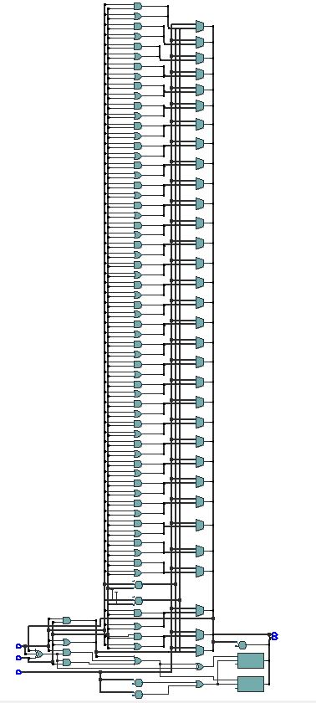

# Completed Table



# VHDL and Test Bench

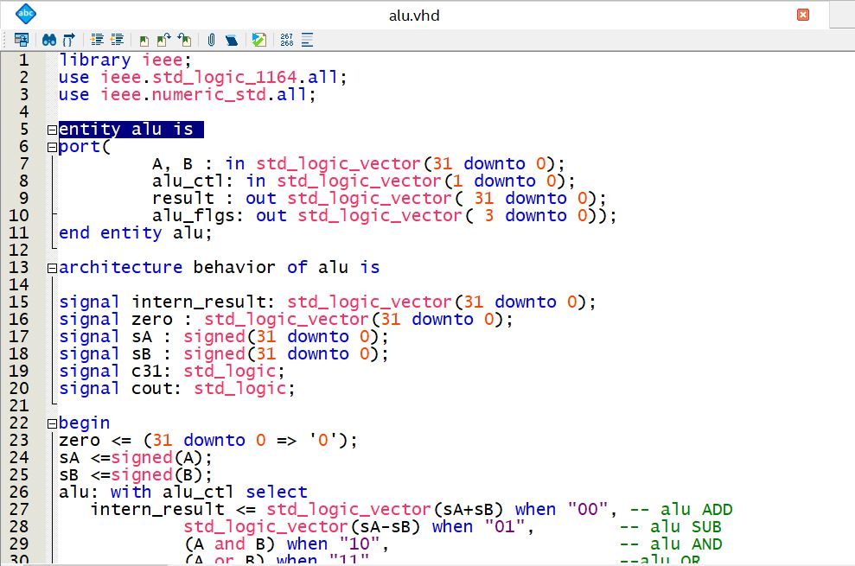

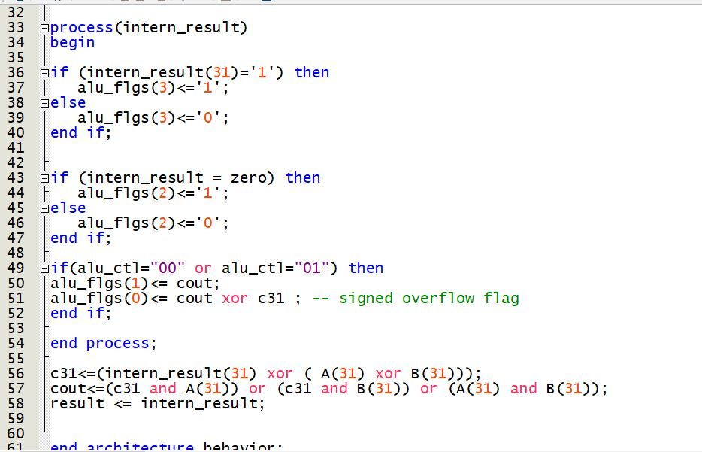

# Simulation Results

